

s

**NATIONAL DRUG AUTHORITY**

**ANNUAL RISK MANAGEMENT**

**REPORT**

**JULY 2021-JUNE 2022**

**HEAD OFFICE**

**Rumee Towers, Plot 19 Lumumba Avenue**

**P. O. Box 23096, Kampala, Uganda**

[**Tel:+256417788100/1**](Tel:+256417788100/1)**, 417788124/04178812 Toll Free: 0800 101 999**

CONTENT PAGE

1.0 EXECUTIVE SUMMARY 1

1.1 Introduction and context 1

1.2 Risk distribution 1

1.3 Risk ranking 2

1.4 Key issues addressed and conclusions 3

1.4.1 Corporate risks outlook 3

1.4.2 Operational risk outlook 3

1.5 Emerging risks outlook 4

1.5.1 Legal and Regulatory operating environment 4

1.5.2 Covid-19 impact and lockdowns; 4

1.5.3 Inflation and other economic hardships 4

1.5.4 Perforation of GOU drugs from regional hospitals and health centers 5

1.5.5 Conflicting regulatory mandate 5

1.6 Key projected risk outlook going forward 5

1.7 Risk Culture Improvement Plan 7

1.8 Status of the overall risk profile and risk opinion 7

2.0 DETAILED RISK MANAGEMENT REPORT 8

2.1 Institutional Background 8

2.2 Risk Profile 8

2.3 Risk Appetite 9

2.2.1 Risk Evaluation Criteria 9

2.3 Corporate risks outlook 10

2.4 Operational risks 12

2.4.1 Operational risk Treatment 12

2.4.2 Directorate risk performance 17

5.0 CONCLUSION 20

6.0 RISK MANAGEMENT FRAMEWORK 21

6.1 Risk Management Structure 21

6.2 Risk Management Process 22

# 1.0 EXECUTIVE SUMMARY

## 1.1 Introduction and context

The National Drug Authority’s (NDA) goal for 2020-20 is “To attain and maintain global best practices in drug regulation by 2025”. As the drug regulatory environment context evolves and strategic objectives become more ambitious, we have further fine-tuned the risk management framework. This report therefore addresses the following purpose.

1. Providing information that enables the Authority to fulfill its responsibilities with respect to risk management oversight.
2. Give an overview of the risks facing the entity and the effectiveness of the existing controls and/or framework.
3. Reporting on status of key risk management activities coordinated by management over the year.

The risk management report is provided by the Risk management function to management for review and to be endorsed by the Audit, Risk and Legal Committee of the Authority. It is provided annually to the Drug Authority to facilitate discussion and decision making.

The organizational risk profile is analyzed in terms of; the number and distribution - how many risks identified throughout the reporting period and their distribution across the organization- among directorates and/or processes, the risk ranking before and after treatment, and the organizational capacity to contain the risks through a dynamic risk management and other traditional controls. The report looked at the corporate risks of NDA as listed in the strategic plan, the operation risks, the emerging risks and gives opinion on the effectiveness of the overall risk management framework.

The Authority adopted a defined risk evaluation criterion in 5X5 matrix and a management action thereof.

## 1.2 Risk distribution

The risk Register captured 71 risks distributed across the organization- in the directorates, departments and units. The office of the Secretary to the Authority (SA) has higher number of risks 34% (24 risks out of 71 risks), Directorate of Corporate Services 32.4% (23 risks out of 71 risks), Directorate of Product Safety and Directorate of Inspectorate and Enforcement 11.3% each (8 risks out of 71 risks) respectively, Directorate of Laboratory Services has 8% (6 risks out of 71 risks) and Directorate of Product Assessment and Registration 3% (2 risks out of 71 risks) as presented in chart below.

Total number of risk – 71, DCS -23, SA – 24, DPS -08, DPAR -02, DLS – 06, DIE -08

## 1.3 Risk ranking

Out of the 71 risks identified and recorded in the Risk Register, 23 (32%) are classified as very high risks, 5 (7%) as high risks, 27(38%) as medium risk, 5(8%) as low risk, and one as very low risk according the to the risk evaluation criteria.

## 1.4 Key issues addressed and conclusions

### 1.4.1 Corporate risks outlook

National Drug Authority’s corporate risks are highlighted in Strategic Plan, stipulating the strategic attention of the Authority and management in regard to risk management. The Corporate risk performance outlook recorded 50%(7/14) risk reduction, steady risks 43%(6/14) and an increase 7%(1/14).

Overall, the following factors influenced the corporate risk outlook of NDA in the financial year;

1. An effective Drug Authority that adopted and is implementation an appropriate 5year strategic plan 2020-2025 with approved risk management framework duly communicated and delegated to management through the Audit, Risk and Legal committee of the Authority to Directorates and risk coordinators and a series of manuals and guidelines developed and reviewed to guide management.
2. The organization maintained a reliable ethical and visible leadership via governance structures and related processes, and corporate culture focused on excellence in execution and fairness in dealing and transparency in reporting. The Drug Authority and Management continued to be stable with a number of key positions filled.

### 1.4.2 Operational risk outlook

There has been 90% general performance improvement (reduction in risk rating) in all risk, 9% of the risks stayed the same and only 1% of the risks increased. This points to the effectiveness of the mitigation measure implemented over the year. However, the underlying factors need to be more examined against a set of parameters in order to reduce the level of subjectivity and bias in analysis by the risk owners. Key highlights in the operational risks. The key features in the Operational risks include;

1. Staff safety and security; Staff at the laboratory continue being exposed to fumes and dangerous chemicals, especially at the chemicals store. The WHO recommended checking after every two years which has not been implemented. Enforcement teams need to enhance their personal security too through undergoing a basic self-defense training.
2. Although, organization continues to employ skilled and experienced workforce, and regularly reviews its policies and practices good internal controls designed to ensure the consistent achievement of relevant objectives, it witnessed 13 cases of staff exits, 6 of which were voluntary resignation and 7 terminations and/or end of contracts.
3. Fleet management and shortage of vehicles posed challenges to directorates in implementing their planned activities.
4. There’s a poor record in disposal of assets and unwanted materials which exposes the organization loss of value and hazardous substances.

## 1.5 Emerging risks outlook

### 1.5.1 Legal and Regulatory operating environment

The clients are becoming more demanding in the area of service delivery quality, timelines and coverage within the country which raises compliance and service delivery standards.

The uncertainty over the pending merger and rationalization of government entities has also had a negative impact on NDA. It hampered the recruitment of staff and affected running contracts. This affected performance not only in terms of low level staffing in some units but it also affected staff morale. This was mitigated by use of temporary staff and interns.

### 1.5.2 Covid-19 impact and lockdowns;

Due to the prevalence of COVID-19, Government of Uganda (GOU) instituted countrywide lockdowns and other public health measures. Whereas lockdowns contributed to the control of the pandemic, they created unintended consequences affecting NDA in particular and many of its stakeholders. Disruptions in people movements including foreign trips affected NDA scheduled GMP inspections, stakeholder sensitizations among others. Reducing of staffing levels and working-home measures affected service delivery timelines. However, NDA Management intervened with possible measures for staff remote working.

### 1.5.3 Inflation and other economic hardships

Inflation and the general increase in the cost of leaving grossly affected the net incomes of the NDA workforce and its clients and or suppliers alike. Management mitigated the risk of skyrocketing costs on staff with the cost of Living Adjustments (COLA). Though the costs may have affected the clients in one part of the commonly imported commodities including equipment supplies, there was a window for COVID-19 related commodities opened which facilitated revenue collection notwithstanding the nominal growth due fees review.

### 1.5.4 Pilferage of GOU drugs from regional hospitals and health centers

Over the year, government drugs have continued to be stolen from public health facilities and sold in private clinics and vendors. This has endangered NDA reputational image in drug regulatory space. There’s need to intensify the enforcement in this area with focus on a multi-sectoral approach.

### 1.5.5 Conflicting regulatory mandate

Some beverages and food supplements have been advertised and sold to the public with claims that they have medicinal and healing properties. This cannot be verified because, largely foods and beverages are regulated by a different government body. The claims that these food stuffs and supplements treat and heal illnesses have largely remained unconfirmed and have put NDA’s image at risk.

## 1.6 Key projected risk outlook going forward

Internal controls are based on the principle of acceptable risk being inherent to the design and implementation of a cost-effective system of internal control. The system includes; a robust quality management system, internal audit function, performance monitoring mechanisms, all focused on adding value whilst rendering reasonable assurance and augment deficiencies when they are detected. The key project risks that require the Authority and Management attention going forward are in the table below;

|  |  |  |  |
| --- | --- | --- | --- |
| SN | Risk categories | Annual risk outlook | Projected risk focus areas. |
| 1 | External Environment | * Inflation and high cost of living * Travel restrictions affecting planned GMP inspections and benchmarking studies * Staffing levels reduction and working home culture * Terrorism | * Watch out for future outbreaks and pandemics (e.g new variants of C19, Ebola) and other disruptive factors. * Perforation of Government drug from the health centers (problems of the supply chain and the reputation of NDA) * Political and economic situation of the country. |
| 2 | Financial Risks | * Credit risk exposure (current arrears with MOH) * Inflation and high cost of living (triggered COLA) | * Fees structure vs real revenue growth * Partnerships for purposes of donor conditions. * Wage bill in view of the raising inflation and General salary structure adjustments by GOU (NDA matching enhanced salaries of scientists in other MDA) * Improve cost efficiency in all operations (cost-to-income ratio) |
| 3 | Governance Risks | * Compliance * Staff turnover –( A total of 13 staff exits, 6 voluntary resignations and 7 terminations/end of contracts) | * Embedded system of values and ethics and maintenance thereof via visible leadership. * Formalized ethics policies and codes of conduct. * Corporate culture focused on excellence in execution and fairness in dealing and transparency in reporting. * Comprehensive and compliant corporate governance structures and systems that fosters accountability and responsibility. |
| 4 | Infrastructural risks | * Construction of the Lab tower | * Completion of the Tower * Planned regional offices |
| 5 | Legal Risks | Merger and rationalization of MDAs. | * Government Mergers and rationalization * Completion of the NFDA Bill |
| 6 | Occupational Health and Safety Risks | * Congested working space * Aeration within the workplace | * Maintain the safety and wellbeing of our staff and create an enabling environment (through stringent safety protocols) |
| 7 | Operational Risks | * Disruptive impact of Covid-19 on operations (movement restrictions and staffing levels) | * Enhance resilience of operations through a robust BCP and DRP * Human capital (enhance performance culture and talent management) * Service quality improvement. |
| 8 | Regulatory Risks | Conflict in the mandate | * Service coverage * Multi-sectoral collaboration |
| 9 | Reputational Risks | Stealing of GOU drugs from health centers and other facilities | * The cost on enforcement |
| 10 | Technological Risk | * System upgrades –NAVISION, NDAMIS * New automations –LIMS – systems procured expensively become unusable * Cyber risk | * Expensive systems installed soon become unusable or need upgrades - |

## 1.7 Risk Culture Improvement Plan

It is important that each business unit incorporates Risk Management in their planning process. This means identifying risks that may affect their set objectives, propose mitigation actions, and commit resources. It is also important that mitigation actions are not just mentioned (like the case in our current work-plans), but should be integrated for implementation. This helps the Risk Management function – coordinators and risk management officer to monitor and report on the risk identified, mitigation actions and the effectiveness of the controls.

Time limes should be given- when the proposed measure is to be implemented, and resources committed during budgeting (risk-based budgeting). This allows the development of a comprehensive risk-treatment plan that is not detached from the work plans of Departments, allows smooth monitoring and reporting, and promotes a rich risk-aware culture.

## 1.8 Status of the overall risk profile and risk opinion

National Drug Authority is still in a moderate stage of maturity of risk management, internal controls and governance, creating well-established and functioning systems, processes, tools and practices, and ensuring the framework is responsive to changes.

The traditional internal controls and risk management process implemented are effective to detect and manage risks. The risk management framework was in place to enable identification of all the risks including responding appropriately to emerging risks.

The Authority is not aware of any exposure or position that could culminate in the residual risk profile exceeding the risk-bearing capacity/appetite limits by the Authority and no significant shifts in the overall risk exposure of the organization have come to the attention of the Risk Management Unit. This implies that finalization of the risk appetite is critical at this point to provide appropriate direction for NDA risk management framework.

During the year, Authority approved the Risk Management manual and framework. Risk management is structured in a such way to achieve integration, inclusiveness, and customization across the whole organization. It is entity-wide to include every process of NDA and allow everyone participate in the risk management process. The report summarizes the structure and roles-from the Authority, to the Audit, Risk and Legal committee of the Authority, to the office of SA, the directorates, the peer review team and the risk coordinators.

This report gives a summary of the controls measures to manage risks with a highlight on the high and very high risks and the key controls implemented thereof. Some proposed mitigations were not implemented (as highlighted in red) in which case, the unit/Department relied on the traditional/existing measures to manage the risks and postponed actions in the subsequent planning period.

# 2.0 DETAILED RISK MANAGEMENT REPORT

## 2.1 Institutional Background

National Drug Authority (NDA) is implementing a five-year Strategic Plan that adopted the risk management approach that is consistent with the Government of Uganda Risk Management Strategy 2018 whose main objective is to facilitate the integration of risk management into national development planning, strategy formulation, annual planning and in all systems and processes.

NDA strategic plan 2020-2025 acknowledges the need for risk-informed development as a process and not an event. This is because there is a continuous interaction across local, regional and global risks including; Regulatory, Human Capital, Legal, External, Reputation, Technology, financial, strategic among others. The Strategic Plan therefore identified, analyzed various potential risks and prescribed possible mitigation, continuous monitoring and management measures during the period.

Over the year, NDA employed sound enterprise risk management principles, transparent decision-making, and effective communication to prioritize risk. NDA manages interrelated categories of risk to effectively regulate and ensure a safe and sound regulatory system that supports drug operators, communities, businesses, and the Ugandan economy.

Throughout the year, the Authority put in place mechanism including a policy manual and framework for risk identification, analysis, treatment, monitoring and reporting to implement the strategic plan. Management integrated risk management in all business processes of NDA.

NDA adopted Enterprise Risk Management (ERM) approach to risk management. ERM is considered an effective entity-wide approach to addressing the full spectrum of the organization’s risks by understanding the combined impact of risks as an interrelated portfolio rather than addressing risks only within silos. ERM calls for understanding the core risks that an entity faces, determining how best to address those risks, and ensuring that the necessary actions are taken.

## 2.2 Risk Profile

NDA identified the risks at core drug regulatory and support process and decision making in view of its strategic objectives (as outlined in the Strategic plan), under the four thematic areas or Sub-programs;

* Core Service delivery,
* Legal and Regulatory Framework,
* Stakeholder awareness, engagement and collaboration and,
* Institutional Capacity.

every activity and level of risk management process requires retention of a record. Risk Management activities (of the risk identification, analysis, evaluation, treatment, recording and reporting, evaluation, monitoring and review are summarized in the Risk Register.

By the end of the year, the risk register had 71 risks distributed across the organization. The risk register is the summary record of the risk management process. Risks have been identified, analyzed, evaluated, treated and monitored over the year. The identified risks in the register have been treated.

## 2.3 Risk Appetite

Risk appetite is defined as the risk that the NDA is prepared or willing to accept without further mitigating action being put in place or the amount and nature of risk the NDA is willing to accept in pursuit of objectives. This is also defined as the risk propensity of the Authority in pursuing the creation of sustainable value for its stakeholders.

The Authority considered both the qualitative and quantitative factors in evaluating risk appetite: risk and return profile of the current investment portfolio; availability of cash; resources and other liquid (available for sale) assets; available funding opportunities; risk return profile of prospective opportunities; financial ratios relevant to measuring performance,

As such, the Authority adopted a defined risk evaluation criterion in 5X5 matrix and a management action thereof. The Risk Owner, uses the risk score obtained from the qualitative or quantitative analysis above shall determine the management action to be taken using the risk ranking guidance table below.

### 2.2.1 Risk Evaluation Criteria

| **Score** | **Risk rank** | **Evaluation Criteria (Management Control Action (MCA)** |
| --- | --- | --- |
| 1 to 4 | Very Low | No mitigation, no action is required, the risk is ALARP (as low as reasonably practicable). Monitor to ensure that the risk remains tolerable at this level. |
| 5 to 8 | Low | Maintain assurance that the risk remains tolerable at this level. Monitor and manage by routine procedures, unlikely to need specific application of resources (managers and key staff). |
| 9 to 12 | Medium | Tolerable if the cost of reduction would exceed the improvement gained. Mitigate through management by specific reviews and monitoring of procedures (Managers) but regular monitoring should occur. |
| 13 to 15 | High | Tolerable only if risk reduction is impractical or if cost is disproportionate to the improvement gained. Mitigate by implementing controls to reduce the risk to as low as is reasonably practicable. Where this cannot happen, continual monitoring should occur. |
| 16 to 25 | Very High | Intolerable, the risk cannot be justified, expect in extraordinary circumstances. Mitigate by ceasing all related activities. |

The risk management process starts with defining the scope, context and the risk criteria by the Authority, followed by risk identification, analysis, evaluation and treatment. Recording and reporting, monitoring and reviver, communication and consultation are iterative processes that continue to run throughout.

### 2.3 Corporate risks outlook

National Drug Authority’s corporate risks are highlighted in Strategic Plan, stipulating the strategic attention of the Authority and management in regard to risk management. There is a reasonable risk movement from high to low according to risk owners.

Overall, the following factors influenced the corporate risk outlook of NDA in the financial year;

An effective Authority that adopted and is implementation an appropriate 5year-term strategy with approved risk management framework duly communicated and delegated to management through the committee to the lower cadre officers and risk coordinators.

The organization maintained a reliable ethical and visible leadership via governance structures and related processes, and corporate culture focused on excellence in execution and fairness in dealing and transparency in reporting.

Maintaining the significance of NDA’s corporate presence through a robust Public relations strategy and communication functions that enables increased visibility and comprehensive stakeholder management.

Stability in the NDA’s cash flow that stood the test of COVID-19 and the lockdowns. This is projected to improve even further, with enhancements in the resource mobilization strategy, upgrade of NAVISON to 365 central and integrating it with NDAMIS, revising the fees structure and introduction of new income lines. Indeed, the cash flow projections indicate an increase by 8% from Ugx 68,383,397,457 to Ugx 73,696,174,243

The table below indicate the risk movement over the year and effectiveness of the mitigation measures implemented in the corporate risks.

|  |  |  |  |  |
| --- | --- | --- | --- | --- |
| Risk | Inherent rating | Residual rating | Risk Movement | Control effectiveness |
| **Strategic objective 1: To improve the operational efficiency and effectiveness that ensure safe, efficacious and quality drugs and health care products.** | | | | |
| Existence of substandard, falsified and unsafe, non-effective products on the market. | 8 | 8 |  | Despite the mitigation measures implemented, the risk could not reduce any further due to the underlying factors like; existence of porous borders, gaps in the collaboration with URA, and the ingenuity of some actors. |
| Breach of Regulatory service standards | 5 | 9 |  | The risk continued to manifest throughout the year without a traceable or documented service complaints handling records. |
| **Strategic Objective.2: To strengthen the legal and regulatory framework for operational effectiveness of NDA** | | | | |
| Deficiency in the law/regulatory as a result of the expanded scope of products for regulation (condoms, masks etc) | 8 | 6 |  | The current scope of law is sufficient for NDA to achieve its given mandate.  The expanded scope of regulation is yet to be covered by the new proposed NFDA Bill 2017. |
| Authority service delivery fail to achieve the agreed standards. | 8 | 4 |  | There have been effective actions to streamline the legal and regulatory framework for operational effectiveness. |
| Authority sued with significant consequence. | 4 | 4 |  | This Risk managed through consensus mechanisms and advocacy. |
| Strategic Objective 3: To increase public awareness, and stakeholder collaboration to support NDA regulatory functions. | | | | |
| Damage to Reputation/Brand of NDA (Reputational Risk) | 12 | 5 |  | Inter Directorate-collaboration, Operationalization of the Internal and External communication and relationship management guidelines effectively reduced the risk. |
| Conflict in regulatory mandate occurs. | 9 | 9 |  | The risk continues to manifest in the field of VET drugs, Medical devices and food supplements with conflicting mandate with Uganda National Bureau of Standards (UNBS). |
| **Strategic objective 4: To strengthen NDA institutional capacity to effectively and efficiently implement its functions, (infrastructure, performance systems, human resource, finance)** | | | | |
| Economic Slowdown/Slow Recovery (Especially because of COVID-19) | 6 | 3 |  | Enhancements in the internal resource mobilization drive, NAVISON upgrades to 365 central, integration of NAVISON and NDAMIS, revising the fees structure and introduction of new income lines led to the reduction in the impact of the risk. Although macroeconomic situation is still volatile, the net impact on NDA’s operations has remained minimal. |
| Staff Safety, Security And Health hazard occurs | 16 | 15 |  | Although this remains an apparent risk, the Safety procedures in place have deterred any big incident. The risk will greatly reduce with increased working space expected at the opening of the new NDA offices. |
| Cyber Attack/Data Breach | 20 | 6 |  | The risk is contained through series of actions; sensitization of users, renewing of the firewall license, NAC installation, the DR site is in place, and will improve further with a completion of a comprehensive DR plan. |
| Business/Financial performance leading to cash flow fluctuations/ liquidity Risk | 6 | 6 |  | This risk has been maintained at a low level. The prevailing macroeconomic conditions in the country (inflation, high COL, increase in fuel prices and prices of consumer goods) have not greatly affected the financial positon of NDA. However, there’s need to conduct a rigorous stress-testing to assess NDA’s long term ability to weather the storm. |
| Failure To Attract and/or Retain Top Talent/Human resource risk | 20 | 12 |  | The entity witnessed 13 cases of staff exits; 6resignations and 7 end of contracts/termination. Management needs to pay attention to the likely effects of the pending mergers and enhancements in salaries of scientists. Although we witnessed a high staff turnover. |
| Third party service providers (vendors/suppliers) fail to perform | 12 | 8 |  | This remains a medium risk with cases of contract extensions, partial executions, and nonperformance. E.g purchase of cars, laboratory equipment. etc. |
| Shortage of infrastructure and facilities to meet the NDA needs | 5 | 6 |  | The status quo remains until the new tower opens.  Also, shortage of vehicles has affected the movement of staff –affecting operations |

## 2.4 Operational risks

There has been a 90% general reduction in all risk, 9% stayed the same and only 1% increased. This points to the effectiveness of the mitigation measure implemented over the year. However, the underlying factors need to be more examined against a set of parameters in order to reduce the level of subjectivity and bias in analysis by the risk owners.

### 2.4.1 Operational risk Treatment

Throughout the year, a number of interventions were implemented both at process or unit/directorate level to manage the identified risks. The table below highlights some of the High risk across NDA distributed under the four strategic objectives and the actions implement by management to mitigate the risks.

The table below summarizes the salient assumptions related to the effectiveness of the controls included in the NDA risk register.

|  |  |  |  |  |  |
| --- | --- | --- | --- | --- | --- |
| **Risk Type/Category** | **Risk Name** | **Inherent risk** | **Residual Risks** | **Change is last financial year** | **NDA's ability to mitigate risks.** |
|  | **Directorate of Inspection & Enforcement** | | |  |  |
| **NDA/REG/DIE-GMP/R006** | Unauthorized drug manufacturers and drug outlets selling medicines. | 16 | 8 |  | Stakeholder engagements seem to yield results (as seen in risk reduction) |
|
|
| **NDA/OPR/DIE-ENF/R007** | Hawkers selling medicines on the market | 20 | 8 |  | The risk seemingly reduced but extra emphasis is needed especially in bus terminals and urban areas. |
| **NDA/ OPR/DIE-ENF/R008** | chain of evidence for impounded drugs compromised. | 16 | 12 |  | Enough office space has been procured including opening of new branch (Soroti) |
|
|
|
|
| **NDA/LEG/DIE-REG/R010** | litigation of NDA due to Implementation of licensing guidelines requirements not supported by NDP/A | 20 | 4 |  | A new regulation drastically reduced the risk. |
|
|
| **Directorate of Product Safety** | | | | | |
| **NDA/OPR/DPS-CT/R017** | Errors in assessment of CT applications & GCP inspections. | 15 | 9 |  | There’s existing plan and budget to manage the risk. |
|
|
| **NDA/OPR/DPS-DP/R023** | Approved drug promotional materials by NDA getting to the public when distorted. | 20 | 10 |  | External company was procured to monitor adverts on media houses. Monitoring survey of media houses to identify unauthorized adverts is planned for Q3 22/23 |
|
|
| **NDA/OPR/DPS-PV/R025** | Delayed or failure to identify signals. | 20 | 12 |  | Capacity enhanced built through recruitment of new staff and training of all. |
| **Directorate of Product Assessment and Registration** | | | | | |
| **NDA/OPR/DPAR/R019** | Entry errors on the CNF list, register and certificate of registration. | 8 | 4 |  | Staff recruited to man ports of entry,  Ongoing upgrade of NDAMIS to integrate with ASCUDA. |
| **NDA/OPR/DPAR/R020** | Disclosure of confidential information in an application to an unauthorized person. | 12 | 8 |  | Confidentiality declarations are signed and restricted distribution of information |
| **Directorate of Cooperate Services** | | | | | |
| **NDA/OPR/DCS-HRM/R052** | Staff Safety, Security And Health hazard | 16 | 15 |  | Safety procedures are in place to reduce the exposure level. |
| **NDA/TECH/DCS-ICT/RO53** | Cyber Attack/Data Breach | 20 | 10 |  | Capabilities are built to manage the risk. |
| **NDA/OPR/DCS-HRM/R054** | Failure To Attract and/Or Retain Top Talent/Human resource risk | 20 | 12 |  |  |
| **NDA/TECH/DCS-ICT/RO60** | Information systems Compromised or failure | 18 | 4 |  |  |
| **NDA/TECH/DCS-ICT/R061** | Breakdown/failure of ICT infrastructure | 12 | 3 |  |  |
| **NDA/TECH/DCS-ICT/R062** | unauthorized access to information systems occurs | 12 | 2 |  |  |
| **NDA/TECH/DCS-ICT/R063** | use of unlicensed or pirated software | 18 | 2 |  |  |
| **NDA/DCS-ICT/R064** | Security breach (Hacking) | 15 | 8 |  |  |
| **NDA/TECH/DCS-ICTP/R065** | implementation of ICT change management fails | 16 | 6 |  |  |
| **NDA/FINA/DCS-FIN/R070** | Credit Risk Exposure | 25 | 16 |  | The debt remains outstanding no matter the interventions made (debt verification with MOH) |
| **NDA/OPR/DCS-HRA/R079** | Accidents | 20 | 12 |  | Safety procedures are in place to manage the risk. It remains a medium risk. |
| **Directorate of Laboratory Services** | | | | | |
| **NDA/OPR/DLS/R011** | Inappropriate exposure of samples leading to possible damage or compromise of results. | 15 | 10 |  | This is a very apparent risk. |
| **NDA/OPR/DLS/R012** | Delayed coding and analysis of samples | 20 | 10 |  | The protocols and procedures in place have reduced the level of risk. |
| **NDA/OPR/DLS/R013** | Exposure to fumes generated from drugs like acaricides. | 25 | 3 |  | Notwithstanding the installed fumes extractor, without a functioning HVAC, the exposure remains high. |
| **NDA/OPR/DLS/R015** | contamination of samples being tested due to the use of un clean glassware. | 15 | 5 |  |  |
| **NDA/OPR/DLS/R016** | Laboratory Accidents occur | 15 | 10 |  |  |
| **Secretary to the Authority** | | | | | |
| **NDA/COM/SA-VET/R027** | Authorization of trials that do not meet the regulatory requirements | 20 | 12 |  |  |
| **NDA/COM/SA-LEG/R035** | litigation. | 20 | 5 |  |  |
| **NDA/REG/SA-LEG/R036** | Failure to facilitate the process of improving the legal mandate of NDA and the proposed extended mandate on food and cosmetics safety | 16 | 12 |  |  |
| **NDA/OPR/SA-PRO/R039** | failure to access the target stakeholders to provide them with shared drug safety information. | **16** | 8 |  |  |
| **NDA/REP/SA-PRO/R043** | Confidential information is publicly released/Leakage of sensitive information | **16** | 1 |  |  |
| **NDA/REP/SA-HARM/R044** | Non-tariff barriers caused by NDA activities at EAC and other international protocols | **25** | 12 |  |  |
| **NDA/OPR/SA-PDU/RO81** | Failure to fully implement the procurement plan | 25 | 4 |  |  |

### 2.4.2 Directorate risk performance

All directorates had an average reduction in the risk levels of 89.3% (DIE -83%, DPS-90%, DPAR -100%, DCS -91%, DLS -100%, SA – 72%). The factors for the reduction in the risk rating, are unique to the directorates but largely influenced the risk perceptions of the risk owners with flashes of some biases.

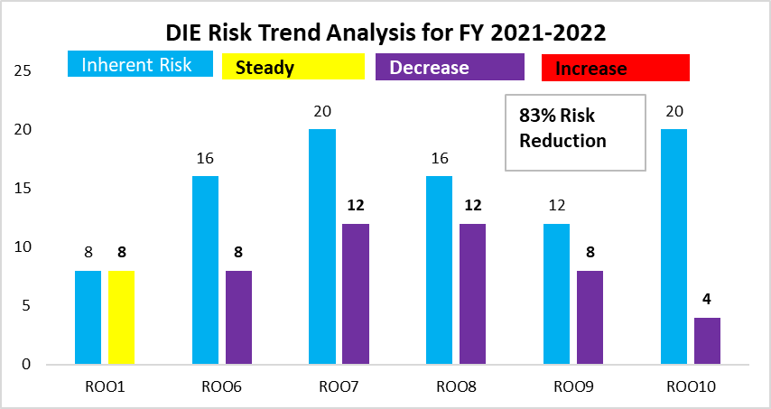

Risk R001 remained unchanged due to the underlying assumptions;

* Existence of porous borders
* Ingenuity of the actors
* Gaps in the collaboration with URA at the ports of entry.

All other risks reduced by 83% due to the controls implemented.

DPS registered 90% reduction in the risk rating as a result of implementing the mitigation measures.

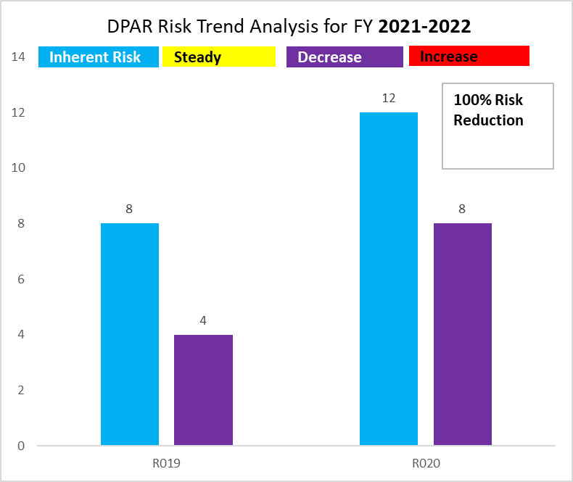

There is a noticeable reduction in the risk ranking under DPAR because of the control measures implemented to eliminate entry errors on the CNF list, register and certificate of registration, and disclosure of confidential information in an application to an unauthorized person.

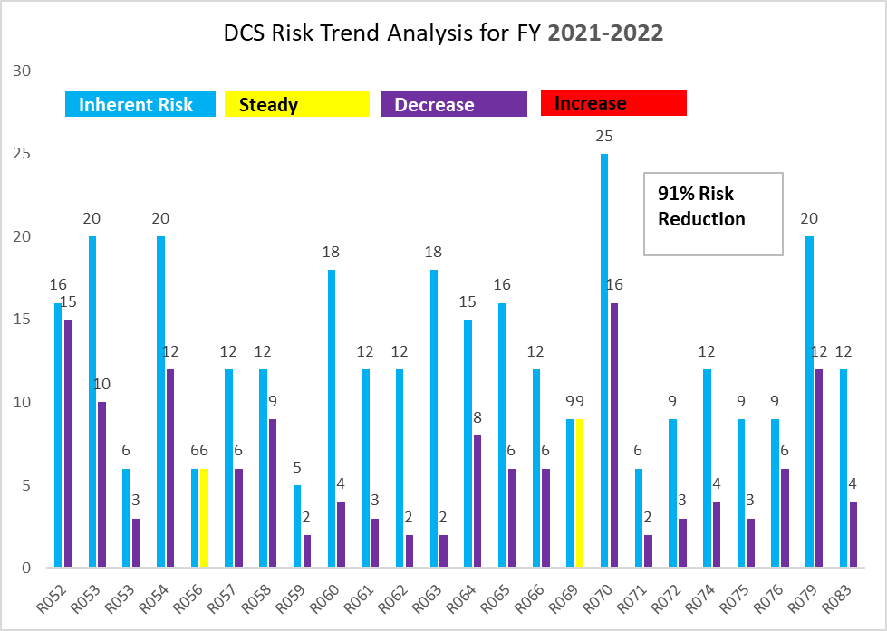

Two risks stayed the same after treatment due to certain underlying factors- R056, NDA continues to grapple with congested work spaces until the new offices open. R069 (Under declaration of proforma invoices going undetected. Miscomputation of verification fees going undetected) remains until NDAMIS is fully integrated with ASCUDA. Otherwise, the directorate saw a 91% reduction in all other risks.

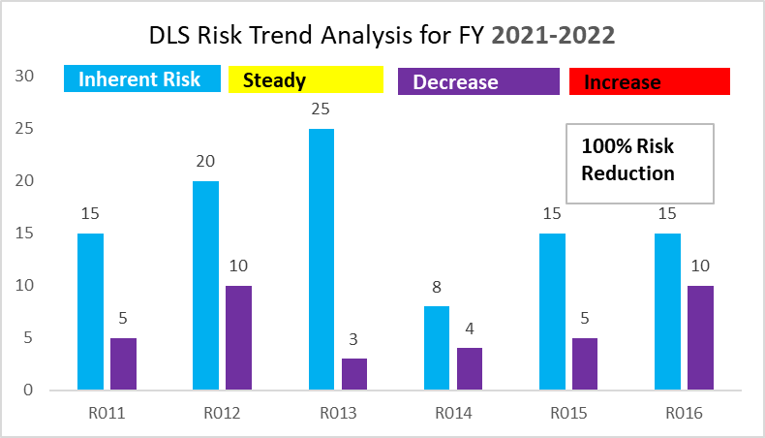

Strong controls are in place and seem sufficient to manage the risks under DLS. The safety and health measure in the lab are hoped to be enhance with the installation of HVAC in the new Lab-tower.

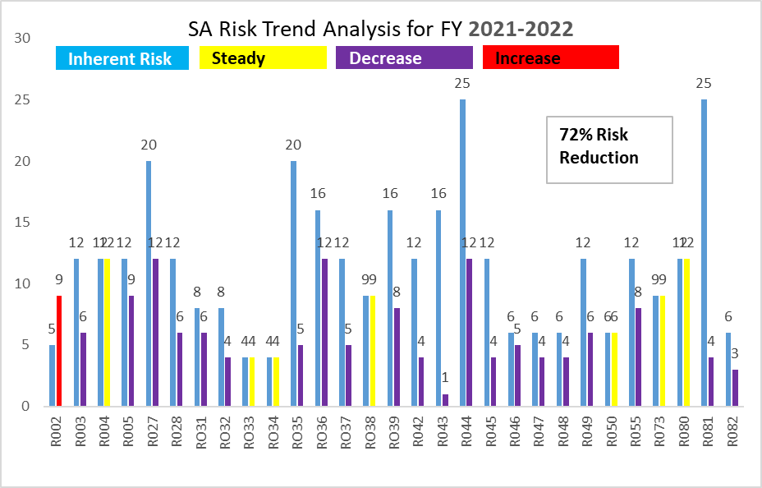

Risk R002 under QMS increased from 5 to 9 indicating gaps in the gaps in meeting regulatory standards.

R004 did not change –pointing to a not changing risk in the antimicrobial resistance.

R038 – Conflict in regulatory mandate continues to manifest.

R080 – Failure to dispose-off obsolete items remain unchanged.

# 5.0 CONCLUSION

The Authority, through the Audit, Risk and Legal Committee, put in place the Risk Management manual, policies, procedures and the comprehensive framework of Risk Management that provide reasonable assurance that value is created and protected for all NDA stakeholders.

This reports spotlights the gaps in the risk management process and the framework as areas that need improvement. There’s need to build a strong risk culture that can be able detect danger and stop risk factors and/or drivers from crystallizing. Management should provide adequate support to the risk function to map out all potential risks and then ensure that those in charge of different business processes work to prevent or best manage the risks. Although it might be impossible to think of all possible risk scenarios and address them, a robust risk management function can make undesirable surprises less likely and less severe if they occur.

# 6.0 RISK MANAGEMENT FRAMEWORK

## 6.1 Risk Management Structure

Risk Management in NDA, is structured in such a way that, it is entity-wide – from the Authority to the lower cadre officers. It is inclusive and customized, well-integrated and involves everyone in the organization.

**The Drug Authority (including the committee)**

The process starts with the Authority that has shown leadership and commitment by;

* defining the context and Scope
* Implementing the components of the framework
* Establishing a policy
* Providing the necessary resources (including the human resources)
* Defining the roles and responsibilities

**Top Management**;

* Has ensured that risks are adequately considered while setting NDA strategic goals
* Ensured that, in pursuit of the goals, risks are properly understood.
* Ensured that systems to identify and manage risks are in place and are operating effectively.
* Ensured that such risks are appropriate in the context of organizational goals
* Created infrastructure to communicate risk across

**Directorates/Departments/Units (Risk owners)**

* Designated a risk coordinator/s in their Directorate, Department or Unit to facilitated the process of Risk Management
* Approved identified risks and opportunities in their respective processes
* Analyse and evaluate the identified risks and opportunities.
* implemented actions to address the risks and opportunities
* Monitored and evaluated, on a quarterly basis, the effectiveness of the actions to address the risks and opportunities.

**Risk Peer Review Team (Risk Coordinators and Risk Owners Representative)**

* Take part in peer review of risks and opportunities identified in the respective functions during analysis and evaluation to determine the appropriate risk treatment before submission to the next stage of review.

**Risk Coordinator for each process**

* Facilitate risk management (identification, analysis, evaluation, treatment, monitoring, review, communication and report) using various assessment techniques and established risk scoring technique at each process.
* Take part in peer review of risks and opportunities identified in their respective functions during analysis and evaluation to determine the appropriate risk treatment.
* Assist the risk owner in the development of risk treatment (threat mitigation and opportunity realization) and associated actions and contingency.
* Contribute to the improvement of risk management within NDA**.**
* Maintain the completeness and accuracy of the data in the functional level risk and opportunities register and to generate risk management reports, on a monthly basis.
* Assist the risk owner in decision making using risk-based thinking**.**

## 6.2 Risk Management Process

* 1. Establishing the context, scope and criteria
* 2. Risk Assessment
* - Identification,
* - Analysis
* - Risk Evaluation
* 3. Risk Treatment
* 4. Recording and Reporting
* 5. Monitoring and Review
* 6. Communication and Consultation



**-END-**